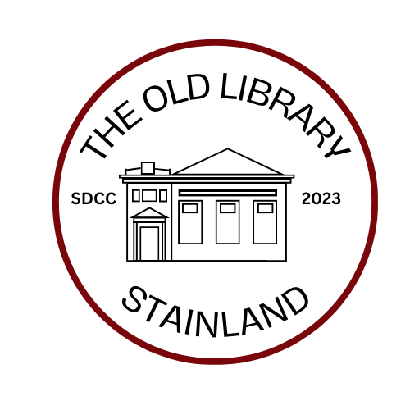

Control of Substances Hazardous to Health Regulations (COSHH) - The Old Library - Risk Assessment.
The law requires any organisation, which uses substances that might cause harm to health, to control the risk to its employees. The Old Library Community Centre has no employees and therefore there is no obligation to record a formal risk assessment but, it makes sense to write down what steps The Old Library Trustees have taken to identify the risks and list any actions they have taken to control the risks to health.
The risk assessment will be reviewed annually to ensure that it is kept up to date and takes into account any changes in the The Old Library Community Centre
Identification of the hazards:
The only substances used in the Community Centre are cleaning products.
These include:
- Floor Cleaner • Toilet Cleaner
- Washing Up Liquid • Surface Cleaner
- Bleach • Polish
All the substances are commonly used in domestic settings and will therefore be familiar to anyone using them in the Community Centre.
Who might be harmed and how?
The regular user of all these substances is limited to a cleaner, which could be several times per month. Community Centre volunteers and users might come into contact with some substances on an irregular once per week basis or less.
Substances could splash onto skin, into eyes or mouth. Liquids could be consumed orally.
Small splashes onto the skin can be washed off with water without harm being suffered.
Small splashes into the eye can be irrigated with water and small splashes into the mouth can be washed out with water. Small levels of exposure onto the skin, into the mouth or into eyes will have no lasting detrimental effect on the users if washed or irrigated immediately.
Wilful misuse could lead to much more serious harm resulting in hospitalisation.
What are the risks and precautions taken?
If used in accordance with the manufacturer’s instruction, users will not be exposed to risk. As all products are different and can have their own specific risks, an exclusive list of products to be used in the Community centre
has been agreed by the Trustees.
These are:- Floor Cleaner - Toilet Cleaner -Washing Up Liquid- Surface Cleaner – Bleach - Multi Surface Polish
Systems of work
Washing up liquid is kept in the kitchen to be used hall users they need to be accessible.
Other substances are kept in the cleaner’s cupboard with access upon request by hall users, volunteers and cleaners only. As all products are domestic in nature, purchased from the local shops, they remain in the manufacturers packaging with clear instructions on use and potential hazards. No chemicals or substances are purchased in bulk and transferred into small containers. All products are used and only packaging is disposed in the appropriate bin in accordance with local authority recycling requirements.
COSHH Product Data Sheet Summary
Only approved cleaning products should be used in the Community Centre. If used in accordance with the manufacturer’s instructions, approved cleaning products will be safe and not hazardous to health.
If cleaning products get onto the skin, they affected area should be washed with soap and water as soon as possible.
If cleaning products are splashed into the eyes, they should be irrigated with water as soon as possible.
If cleaning products are ingested, they should be diluted by drinking copious volumes of water as soon as possible.
Anyone concerned about any misuse of a cleaning product or suffering symptoms after a misuse, they should seek urgent medical attention.

